**PROJECT PROPOSAL**

**CODE SHOOTERS** (Team 9)

**Team Details:**

Team member 1: Bhargavi Sai Poojitha Chennupati (6)

Team member 2: Sai Divya Chennupati (7)

Team member 3: Niteesha Kothinti (31)

Team member 4: Naga Bindu Madamanchi (32)

**Project Goals and Objective:**

To develop an augmented reality application to get nutritional contents of the food or drinks captured using camera at the time of consumption.

**Tools Used:**

Unity 3d, Vuforia Developer, Android Studio.

**System Features:**

Diet on track is a mobile application where users need to login/register to know the nutrition values in food by capturing the food.

1. App will be able to capture the food and estimated quantity will be shown in augmented view after user takes a picture of food.
2. App will display all the nutritional content (including protein, carbs, etc.) of the foods captured by user along with daily calorie count (including protein, carbs, fats, etc.) of all the foods recorded as consumed by the user.
3. App must be able to scan barcode sticker of food/drinks and get the nutrition facts of that product. This application also includes dashboard showing the statistics of the user’s diet and nutrition.

**Project Plan using ZenHub tool:**

* We have created the milestones- Project Plan/Proposal, Increment 1, Increment 2, Increment 3.

* Assigned the tasks(issues) for each increment.

* Assigned the created tasks to each of the member in our team.

* Estimated the story points for each issue.

**Created Issues in ZenHub:**

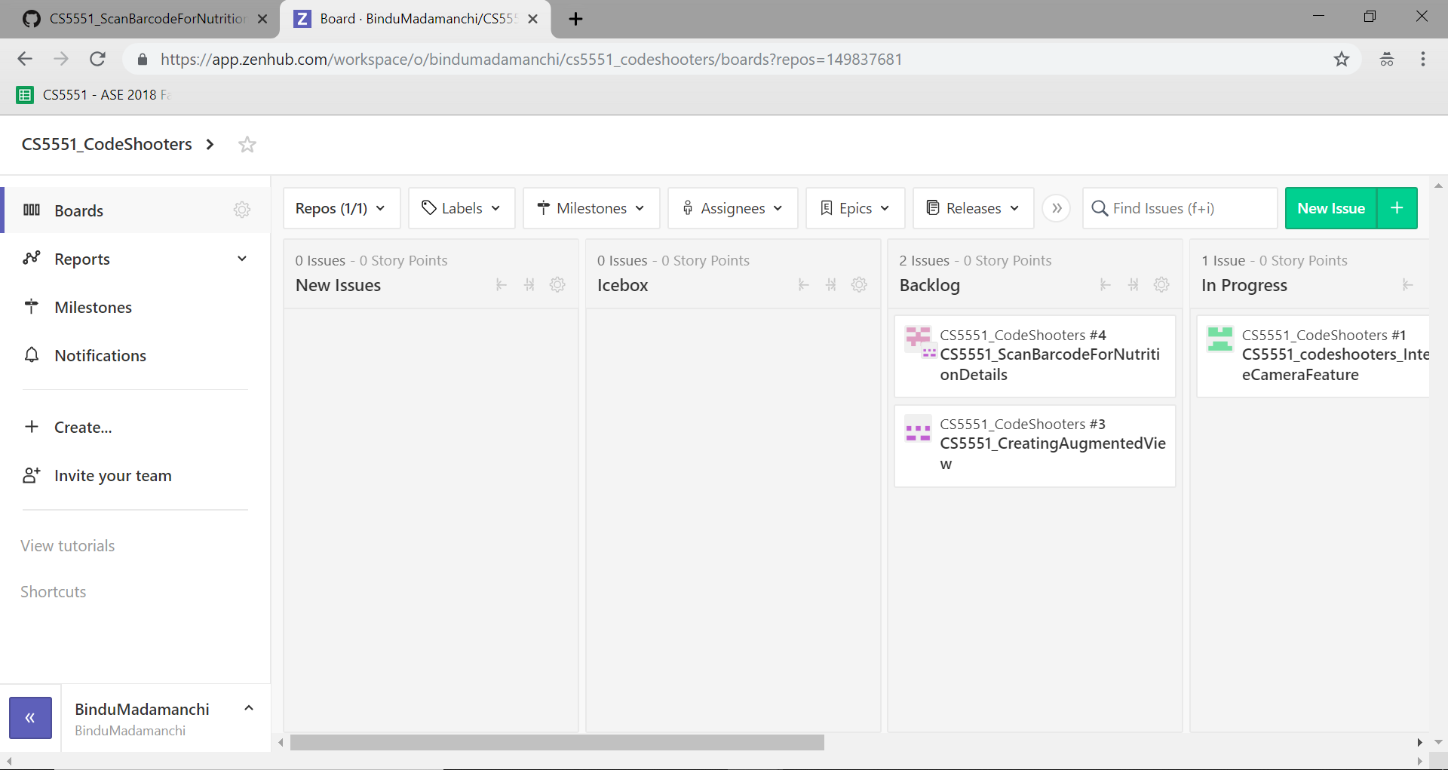

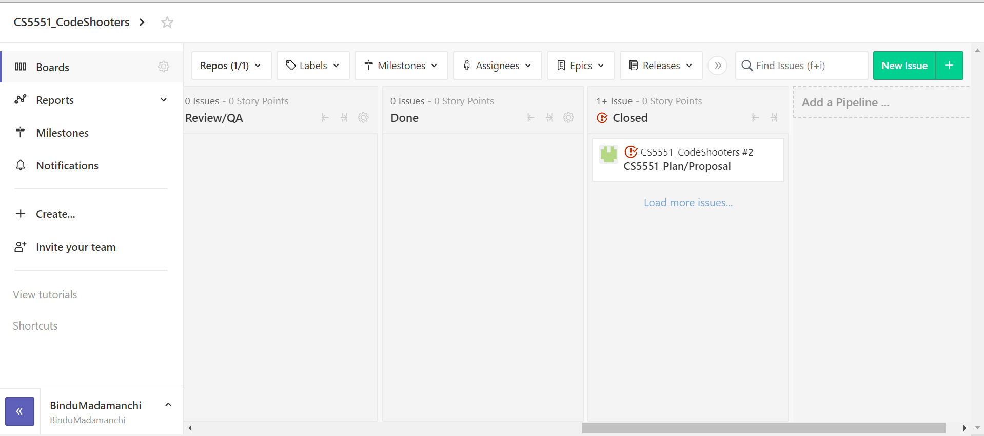

**Burndown Charts for Project Plan/Proposal Milestone:**

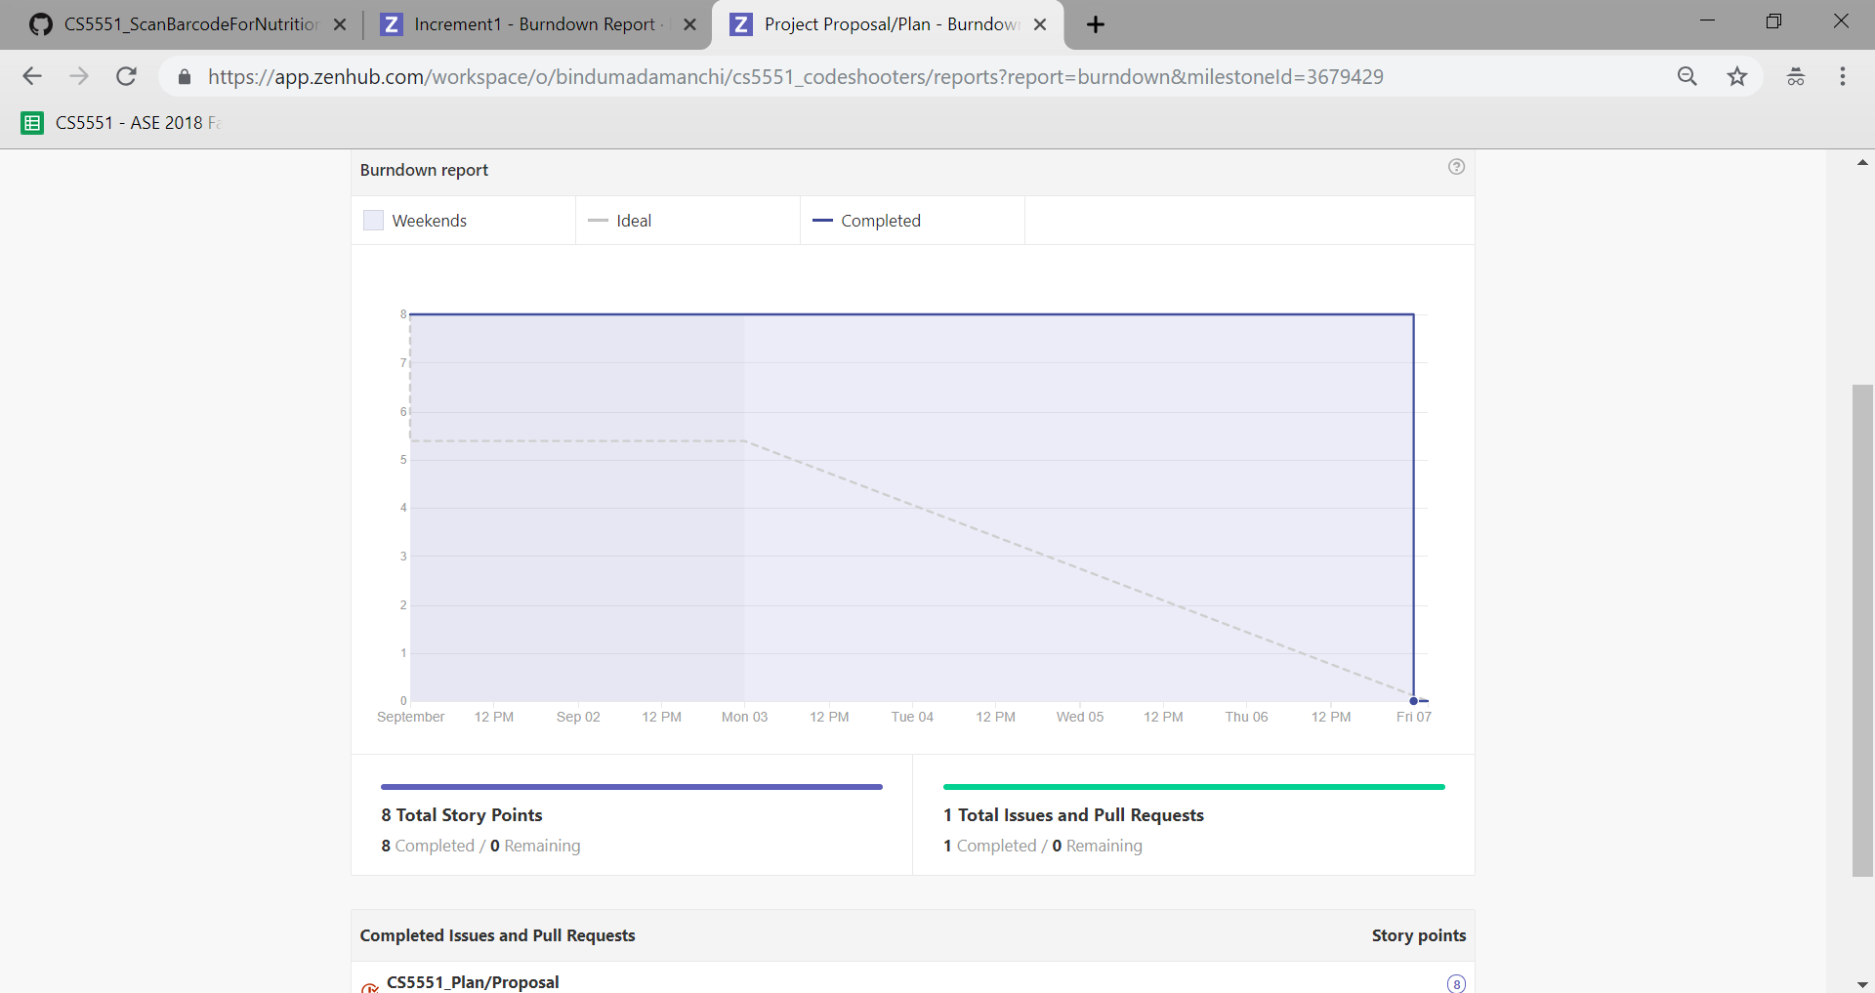

**Bibilography:**

https://www.ideaswatch.com/startup-idea/healthy-food-checker-via-augmented-reality